Multi-objective assessment of a stakeholder-defined portfolio of groundwater and stream management actions in an agricultural basin
Claire Kouba
2025-11-12

1 Fish-Farm Results of 4 HB function formulations
While MARSS models were used as a tool for identifying important functional flows in (KoubaEtAlWatershed2025?), they are unsuitable for this hydrologic scenario outcome forecasting purpose, because they are autoregressive in nature: the forecasting of future fish outcomes requires historical observations of fish outcomes. Therefore, to use MARSS models in estimating the ecological effects of flow changes under different management scenarios, it would be necessary to have historical fish records collected under the different management scenarios, which are not possible.
Consequently, only LASSO models dependent on hydrologic variables (and not including spawner abundance as a predictor) were evaluated as potential tools to forecast the outcomes of flow change on fish reproduction.

1.1 Models of coho reproductive success

1.1.1 LASSO model, juvenile abundance
Table 1: Coefficients for the Hydrologic Benefit function, an emperical estimate of ecological services provided to Chinook salmon by specific functional flows. The predicted value is in units of log10(juveniles per spawner) produced, modeled using only hydrological factors.
Predictor | Value | Greater Hydrologic Benefit value associated with
Intercept | 1.944 | Intercept Term
s1_SP_ROC_Max | -0.041 | Slower max. rate of change, spring recession (as outmigrating smolt)
w1_Wet_BFL_Mag_50 | -0.181 | Smaller wet season baseflows (as eggs and hatchlings)
## png
## 2
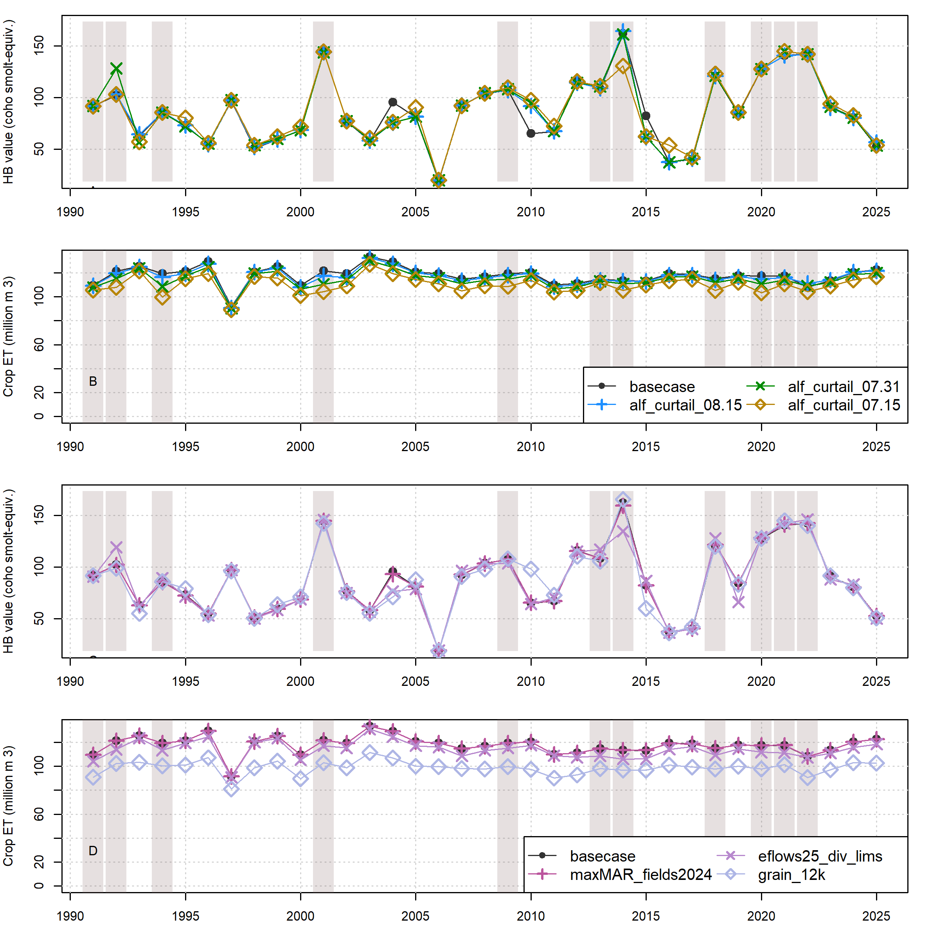
Figure 1: Comparison of annual performance in two objective functions (HB and ET, representing environmental and agricultural objectives, respectively), in the basecase (black circles) and management scenarios (diamond, cross or x symbols) for water years 1991-2025. Panels A and B show comparisons between basecase and one example scenario in each of three categories: Enhanced Recharge, Low Flow Diversion Limits, and Curtailment. Panels A and B show comparisons between basecase and different cutoff dates within the Alfalfa Irrigation category: July 15th, July 31st and August 15th. Dry-type water years (vertical bars) are 1991, ’92, ’94, 2001, ’09, ’13, ’14, ’18, and ’20-’22.
## png
## 2
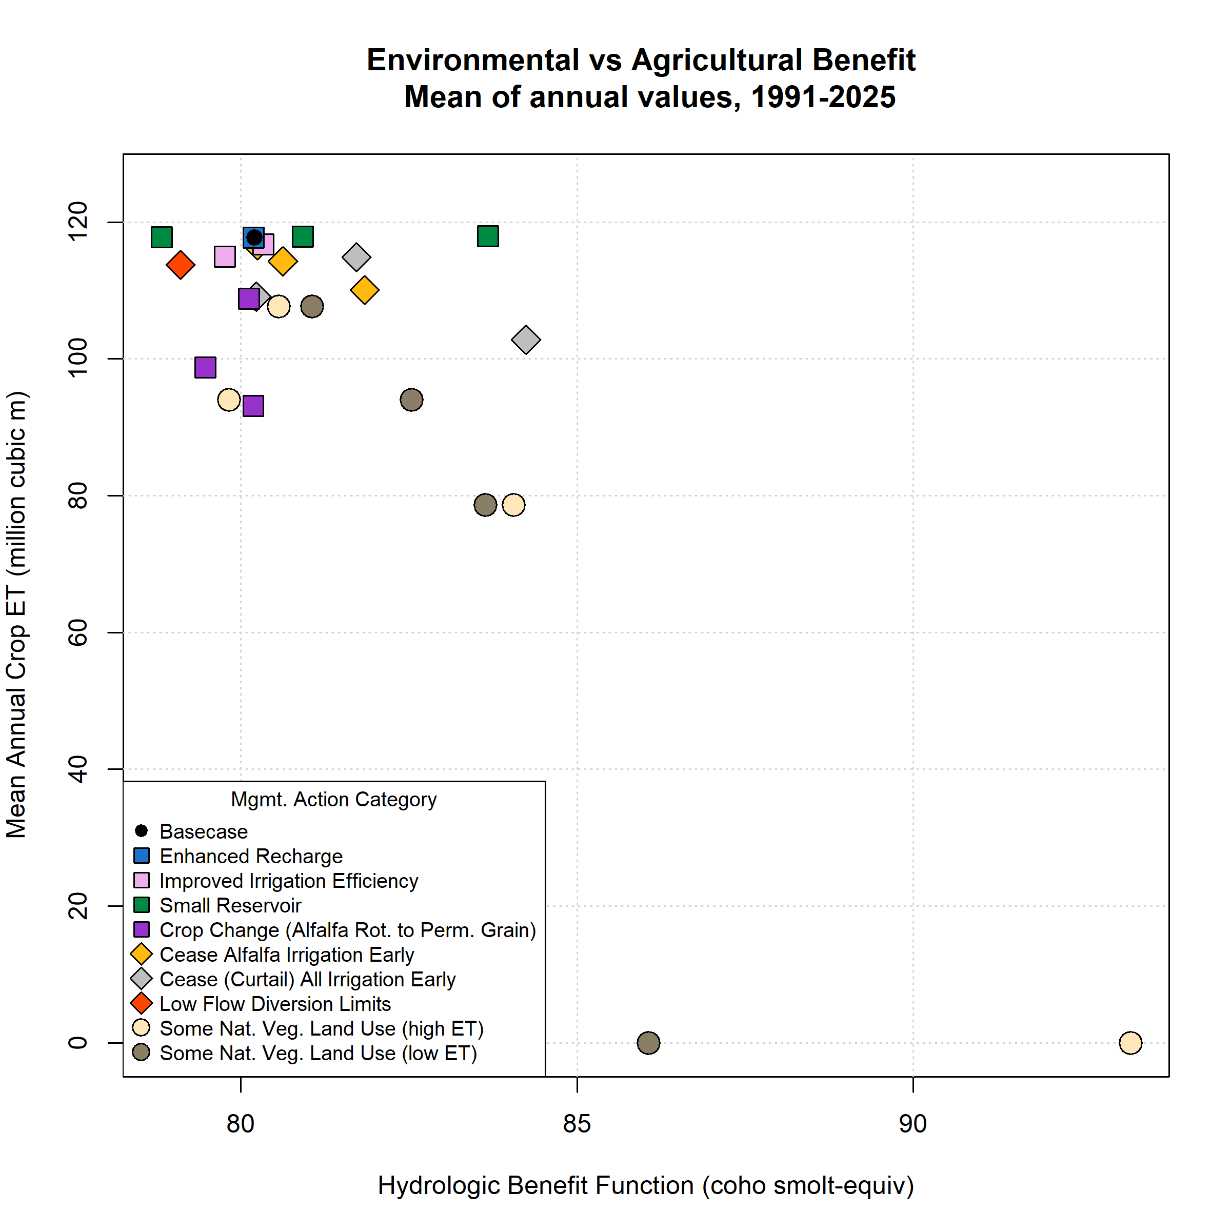
Figure 2: Environmental and agricultural objective function performance (in terms of Hydrologic Benefit, or HB, value; and crop ET volume) for basecase (black circle in upper left) and 39 management scenarios. Symbol x and y coordinates are the average of 28 annual HB and ET values for each scenario over the full model period (water years 1991-2018). Whiskers show standard error of the 28 years of annual HB values; standard errors in the direction of the y-axis are smaller than the height covered by each symbol.
## png
## 2

